**Supporting Information for**

**Charge Balanced Co-doping Enable Exceeding Doping Limit and Ultralow Thermal Conductivity**

**Experimental Section**

**Instrumental Analysis**

The Powder X-ray powder diffraction (XRD) experiments were carried on a Philips X’Pert Pro Super diffractometer instrument with Cu Kα radiation with λ value of 1.54178 Å. The scanning electron microscopy images and energy-dispersive spectroscopy (EDS) mapping profiles were performed on a G450 SEM. The high-resolution transmission electron microscopy (HRTEM) and HRTEN-EDS mapping profiles were conducted on Talos F200X. High-angle annular dark-field scanning transmission electron microscopy (HAADF-STEM) were conducted on JEM-ARM200F. The X-ray photoelectron spectroscopy (XPS) was performed on an ESCALAB MK II X-ray photoelectron spectrometer. The inductively coupled atomic emission spectrometer (ICP-AES) was conducted on iCAP 7400.

**Thermal Transport Property Measurement**

Thermogravimetric analysis (TGA) was conducted on a SDT Q600 instrument in the temperature range of room temperature-1073K at a heating rate of 10K min-1 under Ar flow. The total thermal conductivity was calculated by $\text{κ=D}\text{·Cp·}\text{ρ}$, where the thermal diffusivity coefficient *D* was measured by a Laser flash apparatus (LFA467, Netzsch, Germany) at 298-700K in Ar flow, the specific heat capacity *Cp* is measured with the same instrument meanwhile, and *ρ* were determined by using the dimensions and mass of the pellets.



**Fig. S1.** XRD patterns of AgxBixSn1-2xS (x = 0 ~ 0.06).



**Fig. S2.** Lattice parameters of Sn1-2xAgxBixS as a function of x, deduced from XRD patterns.



**Fig. S3.** Thermogravimetric analysis(TGA) of Sn1-2xAgxBixS (x= 0, 0.01 0.02 0.03)



**Fig. S4.** Specific heat of Sn1-2xAgxBixS(x= 0, 0.01 0.02 0.03) at different temperatures.



**Fig. S5.** Thermal conductivity and thermal diffusivity of SnS as functions of T-1.



**Fig. S6.** Thermal conductivity of SnS, Ag0.03Bi0.03Sn0.94S and Ag0.03Cr0.03Sn0.94S.

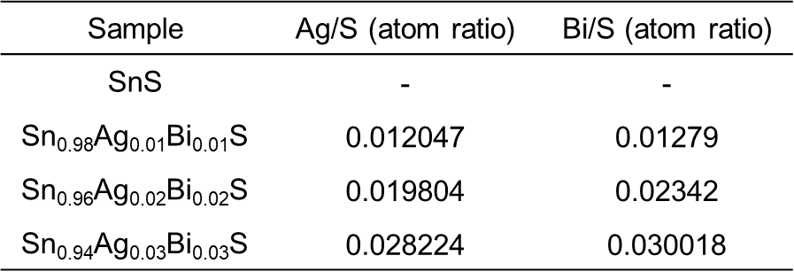

**Table S1.** Inductively coupled plasma atomic emission spectrometry (ICP-AES) measurements of Sn1-2xAgxBixS(x= 0, 0.01 0.02 0.03), normalized by the concentration of S.